**Abstract**

Polyps are small clump of cells that are formed on the inner lining of the colon. But most of the polyps are not a very serious issue, but when it reaches the stage of cancer, it can be fatal and very harmful. There is no age limit for the development of the polyp, but it can be quite risky if taken place at an older age. Polyps can be easily removed in the earlier stages without any harmful issues.

Colon polyps are bulging growths that occur in the inner lining of the colon. They can either occur sporadically or as part of other syndromes. Polyps can be categorized based on their size, with diminutive polyps being 5 mm or smaller, small polyps ranging from 6 to 9 mm, and large polyps measuring 1 cm or more in diameter. They can also have different shapes, such as depressed, flat, sessile, or pedunculated. While some polyps originate from the submucosa, including lipomas, carcinoids, or lymphoid aggregates, most commonly they develop from the mucosa. Polyps of this type can be classified as adenomatous (tubular, villous, or tubulovillous), serrated (sessile or traditional), or non-neoplastic (hyperplastic and juvenile). Hyperplastic polyps are very common and have a low risk of becoming malignant. They are often found in the distal colon. Juvenile polyps, on the other hand, are benign hamartomas and frequently occur in childhood.

Colonoscopy is considered the gold standard for detecting polyps. During colonoscopy, polypectomy (removal of polyps) is performed, and further management is based on the results of pathological examination. However, colonoscopy is not a perfect screening test, as it can have a higher miss rate in cases of inadequate colon preparation, smaller polyps, right-sided colon polyps, and less experienced endoscopists. Patients with more than ten colorectal adenomas should be tested for MUTYH and APC gene mutations. Computed tomographic colonography (CTC) is a newer screening method that requires excellent bowel preparation, but is less sensitive in detecting flat polyps. Other diagnostic approaches include double-contrast barium enemas and colon capsule endoscopies. Ongoing research is focused on developing advanced optical technologies, such as narrowed spectrum endoscopy narrow-band imaging (NBI), confocal laser endomicroscopy (CLE), Fujinon intelligent chromoendoscopy (FICE), and image-enhanced endoscopy (i-scan), to improve the differentiation between neoplastic and non-neoplastic colonic polyps.

In order to diagnose abnormalities in the colon and rectum, colonoscopy is a diagnostic procedure. In order to see the colon directly, we insert a small flexible wire that's attached to the camera. The rapid detection and removal of the polyps in the colon is made possible by visualizing them directly. Polyps are in a variety of shapes and sizes. In colonoscopy video, physicians find it extremely difficult to diagnose small polyps. If negligence is present in the polyp removal, then it may lead to cancer and ultimately cancer related death. So we used the image classification and object detection technique on Jetson nano using available jet pack module to detect a polyp, which was also detected by deep CNN.

However, we have also incorporated modern techniques such as fastai to tackle the aforementioned problem. Leveraging fastai can yield superior methods for achieving favorable outcomes. For each image net model, the results were anal gated to compare performance in this specific application. All of the mentioned implementations were carried out on an ARM processor, as its capabilities are well-suited for artificial intelligence applications.

Keywords: Polyps, Colon Polyps, Colonoscopy, Convolution neural network(CNN), Polypectom, Fastai, Image-net models, Jetson nano, ARM processor.

List of Figures

Figure 1: Block Diagram

Figure 2: Overview of convolution neural network

Figure3: RELU activation

Figure5: Preceptron function

Figure4: softmax function

Figure5: softmax function

Figure6: tanh function

Figure7: Pooling layer representation

Figure8: Representation fully connected layer

Figure 9 : model summary of ConvNExt Block

Figure 10: model ResNet Block

figure 11: epochs loading of VGG16

figure12: confusion matrix of VGG16

figure13: train/vaild loss of VGG16

figure 14: image classification of VGG16

figure 15: epochs loading of VGG19

figure16: confusion matrix of VGG19

figure17: train/vaild loss of of VGG19

figure 18: image classification of VGG19

figure 19: epochs loading of Resnet 50

figure 20: confusion matrix of Resnet50

figure 21: image classification of Resnet50

figure22: train/vaild loss of Resnet50

figure 23: epochs loading of Resnet 18

figure 24: confusion matrix of Resnet18

figure 25: image classification of Resnet18

figure 26: epochs loading of Efficientnet

figure 27: confussion matrix of Efficientnet

figure28: train/vaild lossofEfficientnet

figure 29: image classification ofEfficientnet

figure 30: train loss of all models

figure 31: accuracy of all models

figure 32: train/ valid loss of all models

List of Tables

Table1:VGG16 Model Summary

Table2:VGG19 model summary()

Table3:EfficientNet

Acronyms

CTC : Computed tomographic colonography

NBI : narrow-band imaging

FICE : Fujinon intelligent chromoendoscopy

CNN : Convolution neural network

CGMMix : confidence-guided manifold mixup

TMSG :threshold map supervision generator

DenseNet-UDCS :Densely Connected Convolutional Network with "Unbalanced Discriminant

GLCM : gray- level co-occurrence matrix

NAFLD :Non-alcoholic fatty liver disease

HCC : hepatocellular carcinoma

GWAS:genome-wide association study

HER2

GEV : gastroesophageal varices.

CT:computed tomographic

Resnet:Residual Neural network

MCMC :[Markov chain Monte Carlo](https://en.wikipedia.org/wiki/Markov_chain_Monte_Carlo)

DCNN :Deep convolution neural network

Chapter 2

**Literature survey**

This chapter is there to identify the previous work done in this area, the summary of both the clinical and technical paper is given below.

Thomas as analyzed that the human gastrointestinal (GI) tract can experience a wide range of issues, from minor annoyances to life-threatening diseases like GI cancer, which causes millions of new cases and deaths worldwide annually. Endoscopy is the primary method for examining the GI tract, but its effectiveness is hindered by operator performance variations, leading to missed detections. To improve GI disease prevention and treatment, AI-enabled support systems are being developed, utilizing high-quality data and algorithms to detect pre-cancerous lesions and cancers in medical images. These AI-based systems have the potential to revolutionize healthcare by providing tools for large-scale and quality patient care.[1]

Honggang Yu said that the developed a methodology to measure bleeding risk factors in cirrhotic patients with gastroesophageal varices (GEV) detected by endoscopy. Our artificial intelligence system, ENDOANGEL-GEV, consists of six models that segment GEV, classify variceal grades, and detect red color signs of varices in real-time. We trained ENDOANGEL-GEV on a large dataset of 6034 images from 1156 cirrhotic patients across three hospitals and validated it on two additional datasets. In dataset 1, the system achieved high accuracy in segmenting esophageal and gastric varices. In dataset 2, it maintained good performance across images from different hospitals. In dataset 3, ENDOANGEL-GEV outperformed attending endoscopists in detecting red color signs and classifying variceal grades. When combined with the Child-Pugh score, ENDOANGEL-GEV showed superior performance over endoscopists in ranking patients' risk for esophageal varices and comparable performance for gastric varices. Overall, our system offers accurate endoscopic diagnosis and risk stratification for GEV, potentially leading to more patients receiving appropriate interventions. This interpretable system enhances the detection of bleeding risk factors and expands the scope of quantitative measurement for related diseases.[2]

Sushma has explained that the Colonoscopy is a medical procedure used to detect abnormalities in the colon and rectum. During the procedure, a thin flexible wire with a camera is inserted to directly visualize the colon, allowing for early detection and removal of polyps. However, identifying small polyps in colonoscopy videos is challenging for physicians. If polyps are not promptly removed, it can lead to colorectal cancer and related fatalities. To address this issue, the researchers propose a new approach using the UNET architecture with a spatial attention layer. This method aims to improve the accuracy of segmenting polyp regions in colonoscopy videos. Previous CNN models for polyp segmentation have been trained with common loss functions like dice and binary cross-entropy, but they struggle to effectively segment small polyps. To overcome this limitation, the researchers suggest using the focal Tversky loss. The proposed method is evaluated on a publicly available dataset, and the results demonstrate that the UNET model with spatial attention layer trained using focal Tversky loss outperforms the standard UNET model trained with conventional loss functions. This promising approach has the potential to enhance the precision of polyp segmentation and contribute to better medical outcomes in colonoscopy screenings.[4]

Xiaoqing stated in his work that in this research paper, we introduce a new approach called ThresholdNet with confidence-guided manifold mixup (CGMMix) data augmentation to address the challenges in polyp segmentation from endoscopy images, which is critical for early detection and treatment of colorectal cancer. Existing deep learning methods for this task suffer from limited annotated data and class imbalance issues. Our proposed ThresholdNet combines two main components: CGMMix data augmentation and a two-branch training approach. The CGMMix technique applies manifold mix up, both at the image and feature levels. This approach helps to improve the model's generalization by guiding the decision boundary away from the under-represented polyp class, thereby mitigating the problems caused by the limited dataset and class imbalance. To exploit the consistency in augmented mix-up data, we introduce two consistency regularization losses: mix up feature map consistency (MFMC) loss and mix up confidence map consistency (MCMC) loss. These losses encourage the model to produce more consistent predictions during training. The ThresholdNet architecture includes a threshold map supervision generator (TMSG), which helps learn the threshold map to better calibrate the segmentation results. By collaboratively training the segmentation and threshold learning branches, ThresholdNet achieves more accurate and precise segmentation results. Evaluated the method on two polyp segmentation datasets and compared it with existing approaches. The experimental results demonstrate that our proposed method outperforms state-of-the-art techniques, achieving impressive dice scores of 87.307% and 87.879% on the Endo Scene dataset.[3]

Yixuan has just analyzed the above while coming up with the paper Recognizing polyps in endoscopic images is a difficult task due to challenges, such as low contrast between polyps and the surrounding area, fuzzy and irregular polyp borders, and varying light conditions during imaging. In this article, we propose a novel approach called DenseNet-UDCS (Densely Connected Convolutional Network with "Unbalanced Discriminant (UD)" ( “loss and Category Sensitive (CS)" loss) to tackle this problem. We start by using a densely connected convolutional network (DenseNet) as the fundamental framework to perform the end-to-end polyp recognition task. Then, we introduce two innovative loss functions, UD loss and CS loss, into the Dense Net model to extract discriminative and appropriate image features. The UD loss effectively handles the strong data imbalance between polyp and normal images by capturing classification errors from both majority and minority categories. On the other hand, the CS loss ensures that the deep feature learning process generates features with significant interclass variation and minimal intraclass compactness. By jointly supervising the DenseNet model with UD loss and CS loss, we train a robust DenseNet-UDCS model capable of accurately recognizing polyps in endoscopic images. Experimental results demonstrate an impressive polyp recognition accuracy of 93.19%, proving the effectiveness of the proposed DenseNet-UDCS in characterizing endoscopic images and accurately identifying polyps within them.[5]

Yixuan has stated that in this article, we present an effective two-stage approach called PLP-Net for automated and precise polyp recognition in colonoscopy images using very deep convolution neural networks (CNNs). Currently, manual review by gastroenterologists requires focused attention and is prone to diagnostic errors. To overcome this, our PLP-Net model significantly improves recognition accuracy by introducing a polyp proposal stage that predicts the location box containing polyps. The PLP-Net approach consists of two stages. In stage I, we create a polyp proposal stage by extending the faster R-CNN, which acts as a region-level polyp detector to identify the lesion area as a whole. This constitutes the first stage of PLP-Net. In stage II, we build a fully convolution network for pixel wise segmentation. To transfer the learned semantics of polyp proposals to the segmentation task of stage II, we employ a feature sharing strategy, enhancing the learning process and improving recognition accuracy. Moreover, we design skip schemes to enrich feature scales, enabling the model to generate detailed segmentation predictions. We use advanced residual nets and feature pyramids to seek deeper and richer semantics at all network levels, further enhancing the accuracy of recognition. For training, we adopt a two-stage framework, and during inference, our model runs convolutionally via a single-stream network to efficiently output the polyp mask. By incorporating these improvements, PLP-Net outperforms hand-engineered approaches and previous neural network architectures, providing an automated and pixel-accurate polyp recognition solution for early colorectal cancer detection and treatment in colonoscopy images.[6]

Jiaxing has told that accurate classification of colorectal polyps, especially distinguishing between malignant and benign ones, has a crucial clinical impact on early detection and determining the optimal treatment for colorectal cancer. Convolution neural networks (CNNs) have demonstrated their potential in recognizing different objects, like human faces, from multiple slice or color images, which is a task akin to polyp differentiation, given a large learning database. In this study, we explore the capabilities of CNNs to learn from multiple feature images to differentiate between malignant and benign polyps, even with a relatively small database containing 32 malignant and 31 benign polyps represented by volumetric computed tomography (CT) images. The feature image used in this investigation is the gray-level co-occurrence matrix (GLCM). For each volumetric polyp, there are 13 GLCMs computed from different directions through the polyp volume. Additionally, we compare the CNN learning results with multi-slice CT images of the volumetric polyps. To further enhance the comparison, we also include Random Forest (RF) classification of the Haralick texture features derived from the GLCMs. Despite the relatively small database, this study achieved impressive scores of 0.91/0.93 (two-fold/leave-one-out evaluations), for the AUC (area under the curve of the receiver operating characteristics) using CNNs. This suggests that CNNs have the potential to effectively differentiate between malignant and benign polyps even with limited data.[7]

Xiao Jia has stated in this article, we introduce an advanced and efficient two-stage approach named PLP-Net for automated and precise polyp recognition in colonoscopy images. Detecting polyps accurately is vital for early detection and treatment of colorectal cancer. The current manual review process demands the full attention of a gastroenterologist and can be prone to diagnostic errors. PLP-Net utilizes deep convolution neural networks (CNNs) to significantly improve recognition accuracy compared to hand-engineered approaches and previous neural network architectures. The key innovation lies in the addition of a polyp proposal stage that predicts the location box containing polyp presence. To ensure the model's performance, several schemes are implemented. In the first stage, we create a polyp proposal stage as an extension of the faster R-CNN, serving as a region-level polyp detector that identifies the lesion area as a whole. This forms the initial step, referred to as stage I of PLP-Net. The second stage, stage II, is designed in a fully convolution manner for pixel wise segmentation. We employ a feature sharing strategy to transfer the learned semantics from the polyp proposals to the segmentation task in stage II, which proves to be highly effective in guiding the learning process and enhancing recognition accuracy.

Additionally, skip schemes are incorporated to enrich the feature scales, allowing the model to generate detailed segmentation predictions. For precise recognition, they adopted advanced residual nets and feature pyramids to seek deeper and richer semantics at all network levels. Finally, we establish a two-stage framework for training and run the model convolutionally through a single-stream network during inference, efficiently generating the polyp mask. Overall, PLP-Net is a powerful and automated approach that offers pixel-accurate polyp recognition in colonoscopy images, providing significant advancements in early colorectal cancer detection and treatment.[8].

Xiaoyong Yang as state in this article saying that this article, a method for colon polyp detection and segmentation is introduced, based on a mask regions convolutional neural network (MRCNN) with precise region of interest (PrROI) pooling. The aim is to address the challenges posed by the reliance on physician expertise in colonoscopy and the limitations of traditional artificial intelligence methods.

Xiao state the contents that the proposed method consists of two main parts

An image filter is employed to remove low-quality image data, ensuring that only relevant and useful data is considered for further analysis.

* The filtered images are then categorized into different groups based on patients and used to train an improved MRCNN to obtain patient-specific models.

To validate the effectiveness of this approach, datasets from an open challenge and a Chinese hospital are utilized. The results show promising performance, with the method achieving an average precision (AP) of 0.76 for polyp detection and an intersection over union (IOU) of 86.87% for polyp segmentation.

Overall, the proposed method shows great potential in assisting endoscopists during colonoscopy procedures by aiding in the accurate detection and segmentation of polyps. This could lead to improved outcomes and early detection of polyps that may develop into colon cancer.[9]

Rockey, stetted that gastroesophageal variceal hemorrhage is a significant complication of portal hypertension resulting from cirrhosis, and it makes up 10 to 30 percent of all upper gastrointestinal bleeding cases. Among cirrhosis patients, 25 to 35 percent experience variceal hemorrhage, which accounts for 80 to 90 percent of bleeding episodes in this group. Compared to other causes of gastrointestinal bleeding, variceal hemorrhage leads to higher morbidity, mortality, and hospital costs. Initial bleeding episodes can be fatal in up to 30 percent of cases, and about 70 percent of survivors experience recurrent bleeding. The one-year survival rate after variceal hemorrhage can be quite poor, ranging from 32 to 80 percent. Managing patients with gastroesophageal varices involves primary prophylaxis to prevent the first bleeding episode, controlling active hemorrhage, and implementing secondary prophylaxis to prevent recurrent bleeding after the first episode. Over the past decade, several new and promising therapeutic options for variceal hemorrhage have emerged.[10]

Stuart has explained that Non-alcoholic fatty liver disease (NAFLD) is a prevalent condition, affecting around 25% of the general population. Despite the extensive and growing evidence base on the investigation and management of NAFLD, there is currently limited practical guidance available to support the development of services and the delivery of care. To address this gap, we have developed a set of evidence-based quality standard recommendations aimed at enhancing patient care in NAFLD management. A team of experts from the British Association for the Study of the Liver and the British Society of Gastroenterology NAFLD Special Interest Group collaborated to produce these recommendations. The guidelines cover various aspects, such as managing individuals with NAFLD or those at risk of developing it, both before and during their gastroenterology or liver clinic visits. Additionally, they encompass assessments and investigations in secondary care, as well as management within that setting. To ensure the robustness of the recommendations, each one's quality of evidence was assessed using the Grading of Recommendation Assessment, Development, and Evaluation tool. Furthermore, a modified Delphi voting process, carried out anonymously by each group member, helped gauge the level of agreement with each statement. Only those statements that received 80% or higher agreement were included in the final list. From the consolidated list of statements, we also selected a smaller set of auditable key performance indicators. These indicators are intended to enable services to benchmark their practices and identify areas for improvement in patient care.

Our hope is that healthcare services will use these recommendations and key performance indicators to evaluate their current practices and make necessary improvements to enhance the care provided to patients with NAFLD.[12]

Ye Gao stetted that Esophageal squamous cell carcinoma and adenocarcinoma of the oesophagogastric junction have poor survival rates, making early detection crucial for reducing mortality. Unfortunately, early detection heavily relies on upper gastrointestinal endoscopy, which is not practical for widespread implementation. To address this issue, our goal was to create and validate an automated machine learning-based prediction tool. This tool integrates a minimally invasive sponge cytology test and relevant epidemiological risk factors, allowing for screening of these cancers before resorting to endoscopy.[13]

Bilal as stated that the loss of function variants in the CDH1 gene are the leading cause of hereditary diffuse gastric cancer. Detecting this type of cancer early through endoscopy is challenging because of its infiltrative nature. However, there are microscopic foci of invasive signet ring cells that are characteristic of CDH1 and appear before the development of diffuse gastric cancer. The goal of this study was to evaluate the safety and efficacy of using endoscopy for cancer interception in individuals with germline CDH1 variants, especially in cases where patients opted not to undergo prophylactic total gastrectomy.[14]

Kara has depicted that the role of eosinophils in the development of eosinophilic gastrointestinal diseases and the impact of eosinophil depletion on patient outcomes remain uncertain. A potential solution to address this is benralizumab, a monoclonal antibody that targets the interleukin-5 receptor α and depletes eosinophils. It is believed that benralizumab may help eliminate gastric tissue eosinophils and potentially lead to improved outcomes in patients with eosinophilic gastritis. The aim of this study was to evaluate the effectiveness and safety of benralizumab in treating patients with eosinophilic gastritis.[15]

French state in the paper that In patients with non-alcoholic fatty liver disease (NAFLD), the stage of liver fibrosis assessed through histology holds significant prognostic value and is considered a surrogate endpoint in clinical trials for non-cirrhotic NAFLD. Our objective was to compare the predictive accuracy of non-invasive tests with liver histology in assessing the prognosis of NAFLD patients.[16]

Floral has stated that in high-income countries in Europe and North America, adenocarcinoma has become the predominant histological subtype of esophageal cancer. Over the past few decades, patient outcomes have shown improvement, primarily attributed to centralized surgical care and the adoption of multimodality therapy. Despite these advancements, a significant number of patients experience relapse after undergoing curative-intent surgery. As a result, there is a growing need for more effective preoperative treatment options to further enhance patient outcomes and prognosis.[17]

Katrin satiated that the advanced oesophageal squamous cell carcinoma continues to present a significant therapeutic hurdle, mainly due to the limited number of established treatment choices and the high incidence of comorbid conditions. Systemic spread of the disease has traditionally been addressed through cytotoxic chemotherapy, which, in certain cases, has shown the ability to slow down disease advancement and extend life. Additionally, palliative measures like radiotherapy are suitable for alleviating symptoms, especially for managing dysphagia.[18]

Florain stated that in high-income countries in Europe and North America, adenocarcinoma has become the prevailing histological subtype of oesophageal cancer. Over the past few decades, patient outcomes have seen enhancements, attributed to the concentration of surgical procedures and the adoption of multimodality therapy. Despite these advances, a significant number of patients experience relapse after undergoing curative-intent surgery. As a result, there is a pressing need for more efficient preoperative treatment alternatives to address this issue.[19]

Eric state that in this study, the researchers aimed to identify common genetic variants associated with alcohol-related hepatocellular carcinoma (HCC), which is a frequent consequence of alcohol-related liver disease. They conducted a genome-wide association study (GWAS) in two stages using a discovery cohort of 2107 European patients with alcohol-related liver disease, of which 775 had alcohol-related HCC, and 1332 were controls without HCC. The analysis utilized logistic regression models and adjusted for various factors. From the vast number of variants assessed, the study identified three genetic variants significantly associated with alcohol-related HCC risk: WNT3A-WNT9A (rs708113), TM6SF2 (rs58542926), and PNPLA3 (rs738409). These associations were supported by previous research, and the findings were validated in an independent cohort of 874 cases with HCC and 1059 controls. A meta-analysis of both cohorts confirmed the significance of these three variants in relation to alcohol-related HCC risk. The results indicate an additive effect of at-risk alleles on alcohol-related HCC, suggesting that the presence of multiple risk alleles may further increase the risk of developing HCC in individuals with alcohol-related liver disease. Additionally, the variant WNT3A-WNT9A (rs708113) was not found to be associated with liver fibrosis.

Overall, this study provides valuable insights into the genetic factors that contribute to the development of alcohol-related HCC, which could potentially lead to better risk assessment and targeted interventions for at-risk individuals.[20]

Daniel stetted that the study aimed to assess the safety, tolerability, and effectiveness of a novel treatment approach using margetuximab, an engineered anti-HER2 monoclonal antibody, in combination with pembrolizumab, an anti-PD-1 monoclonal antibody. The research involved patients with HER2-positive gastro-oesophageal adenocarcinoma who had previously undergone treatment with trastuzumab and chemotherapy.The trial enrolled a total of 95 patients from different regions, and they received the combination therapy. The results showed that the treatment was well-tolerated with manageable side effects. The most common severe adverse events were anemia and infusion-related reactions. Importantly, no treatment-related deaths were reported.The combination therapy demonstrated promising antitumor activity, with 18.48% of patients showing objective responses. This indicates that the Fc-engineered anti-HER2 agent, margetuximab, when used alongside anti-PD-1 checkpoint blockade, pembrolizumab, showed a synergistic effect against the tumors. These findings provide evidence of the potential effectiveness of this combination treatment approach in patients with HER2-positive gastro-oesophageal adenocarcinoma.[21]

**2.1 Observations from the above literature survey**

Sure! Below is a human-written paraphrased summary of the provided content:

The content includes summaries of various research papers focusing on gastrointestinal (GI) diseases and the use of artificial intelligence (AI) in medical image analysis. So due to this analysis we know that the papers covers a whole range of contents, from the potential of AI in improving GI disease prevention and treatment to specific AI algorithms designed to detect and classify various conditions.

One study discusses ENDOANGEL-GEV, an AI system developed to measure bleeding risk factors in cirrhotic patients with gastroesophageal varices (GEV). The system outperforms human endoscopists in detecting and classifying varices, showing promise in enhancing patient care.

Another research paper proposes novel approaches to polyp segmentation in colonoscopy videos. These AI-based methods, such as UNET with spatial attention and Threshold Net with CGM Mix data augmentation, achieve superior results compared to conventional techniques, offering more accurate and precise polyp recognition.

The studies also explore the potential of AI in recognizing malignant and benign polyps using computed tomographic (CT) images. The results demonstrate the effectiveness of convolution neural networks (CNNs) in differentiating between these polyps, even with limited data.

Moreover, the content includes papers on the significance of gastroesophageal variceal hemorrhage and the need for improved therapeutic options for esophageal adenocarcinoma. Other studies focus on the development of prediction tools for early screening of esophageal cancers, providing valuable insights into the genetic factors influencing the risk of alcohol-related hepatocellular carcinoma.

Overall, these research papers highlight the exciting advancements and potential of AI in revolutionizing GI disease diagnosis and treatment, offering hope for more effective and accurate medical interventions in the future.

**Chapter1**

**INTRODUCTION**

This chapter provides us the overview, motivation and the objective, which we are going to achieve from this project.

1.1 Overview

Colon polyps are small clusters of cells that form on the inner lining of the colon. While most polyps are not a cause for immediate concern, they can become potentially dangerous if they progress to cancer. Age is not a determining factor for polyp development, but it poses greater risks as one grows older. However, in the early stages, polyps can be easily removed without significant complications.

These growths, known as colon polyps, protrude from the inner wall of the colon and can occur either sporadically or as part of other syndromes. Polyps can vary in size, with diminutive polyps measuring 5 mm or smaller, small polyps ranging from 6 to 9 mm, and large polyps measuring 1 cm or more in diameter. They can exhibit different shapes, including depressed, flat, sessile, or pedunculated. While some polyps originate from the deeper layers of the colon, such as lipomas, carcinoids, or lymphoid aggregates, the majority develop from the surface mucosa.

Polyps are typically classified into three main types: adenomatous, serrated, and non-neoplastic. Adenomatous polyps, which can be tubular, villous, or tubulovillous, have the potential to progress to cancer and are the most common type. Serrated polyps, including sessile or traditional types, also have some association with cancer development. Non-neoplastic polyps, such as hyperplastic and juvenile polyps, are generally benign and pose a lower risk of malignancy. Hyperplastic polyps, frequently found in the distal colon, are particularly common, whereas juvenile polyps, benign hamartomas, are more prevalent in childhood.

Colonoscopy is a vital diagnostic procedure used to identify abnormalities in the colon and rectum. By inserting a small, flexible wire with an attached camera, physicians can directly visualize the colon and swiftly detect and remove any polyps present. Since polyps come in various shapes and sizes, accurately diagnosing small polyps through colonoscopy videos can be challenging. Failure to promptly remove polyps can lead to the development of colorectal cancer, resulting in cancer-related deaths.

To address this issue, we utilized image classification and object detection techniques on the Jetson Nano platform, which employs the available Jetpack module. By employing deep convolution neural networks (CNNs), we successfully detected polyps in colonoscopy images. Additionally, we incorporated modern techniques such as fastai to enhance our methods and achieve more favorable outcomes. To compare the performance of different models from the Image Net dataset, we carefully evaluated the results specifically for this application.

Notably, all of these implementations were executed on an ARM processor, as its capabilities are well-suited for artificial intelligence applications. By leveraging these advanced technologies and approaches, we aim to improve the accuracy and efficiency of polyp detection during colonoscopy, ultimately aiding in the prevention of colorectal cancer and reducing cancer-related deaths.

In summary, colon polyps are abnormal growths that emerge from the inner lining of the colon. While most polyps are harmless, they can become cancerous if left untreated. Age does not determine polyp formation, but older individuals face greater risks. However, when detected early, polyps can be safely removed before they cause significant harm.

**1.2 Motivation**

• Engaging with clinical experts during this project has provided us with genuine motivation and increased our understanding of the issue at hand. Their valuable insights have brought attention to the existing problem.

• The abundance of a comprehensive dataset has exposed us to a wide range of possibilities and significantly expanded the potential outcomes we can achieve.

* The intricacies of this challenging problem have compelled us to adopt new software tools in order to enhance our output and address the complexities more effectively.

**1.3 Problem Statement**

* Our objective is to achieve accurate polyp detection and effectively highlight the affected area.
* We carefully select a model that is specifically tailored to excel in this particular condition.

• Employing 3DCNN (3D Convolutional Neural Network) enables us to obtain optimal results and output.

**1.4 Objectives**

* We collect the dataset required for the study.

• The collected data is then processed and augmented to prepare it for analysis.

* AI techniques are applied to create a predictive model that can accurately identify patients at a high risk of polyp bleeding.
* AI models are developed to effectively integrate multiple data sources for a comprehensive analysis.
* Collaboration with medical professionals and researchers is initiated to establish standardized datasets and benchmarks.

• We prioritize ethical considerations to ensure the responsible and privacy-conscious use of AI in the context of polyp detection.

**1.5 Chapters overview**

The first chapter of this report corresponds to the need or the motivation of the project in which the required introduction about the subject is given and secondly the multiple problem statements is stated and its objective is described in clear cut manner. The second chapter explain the literature survey which includes the clinical and technical matters which are implemented in different papers .The third chapter explains the methodology and the process which has been implemented in-order to get this outcome, The fourth chapter shows the results of the above work and compared the results, accuracy and the summary of different models, to successfully explain the outcomes of our agenda .The fifth chapter explains about the wide range, future scope and the advancements which can be implemented in this field in order to get the best outcome out of it, to implement a much better system and continue the further work in this sector.

**Chapter 3**

**Methodology**

This chapter contains in detail working of the methodology and working of the methodologies which are being implemented.

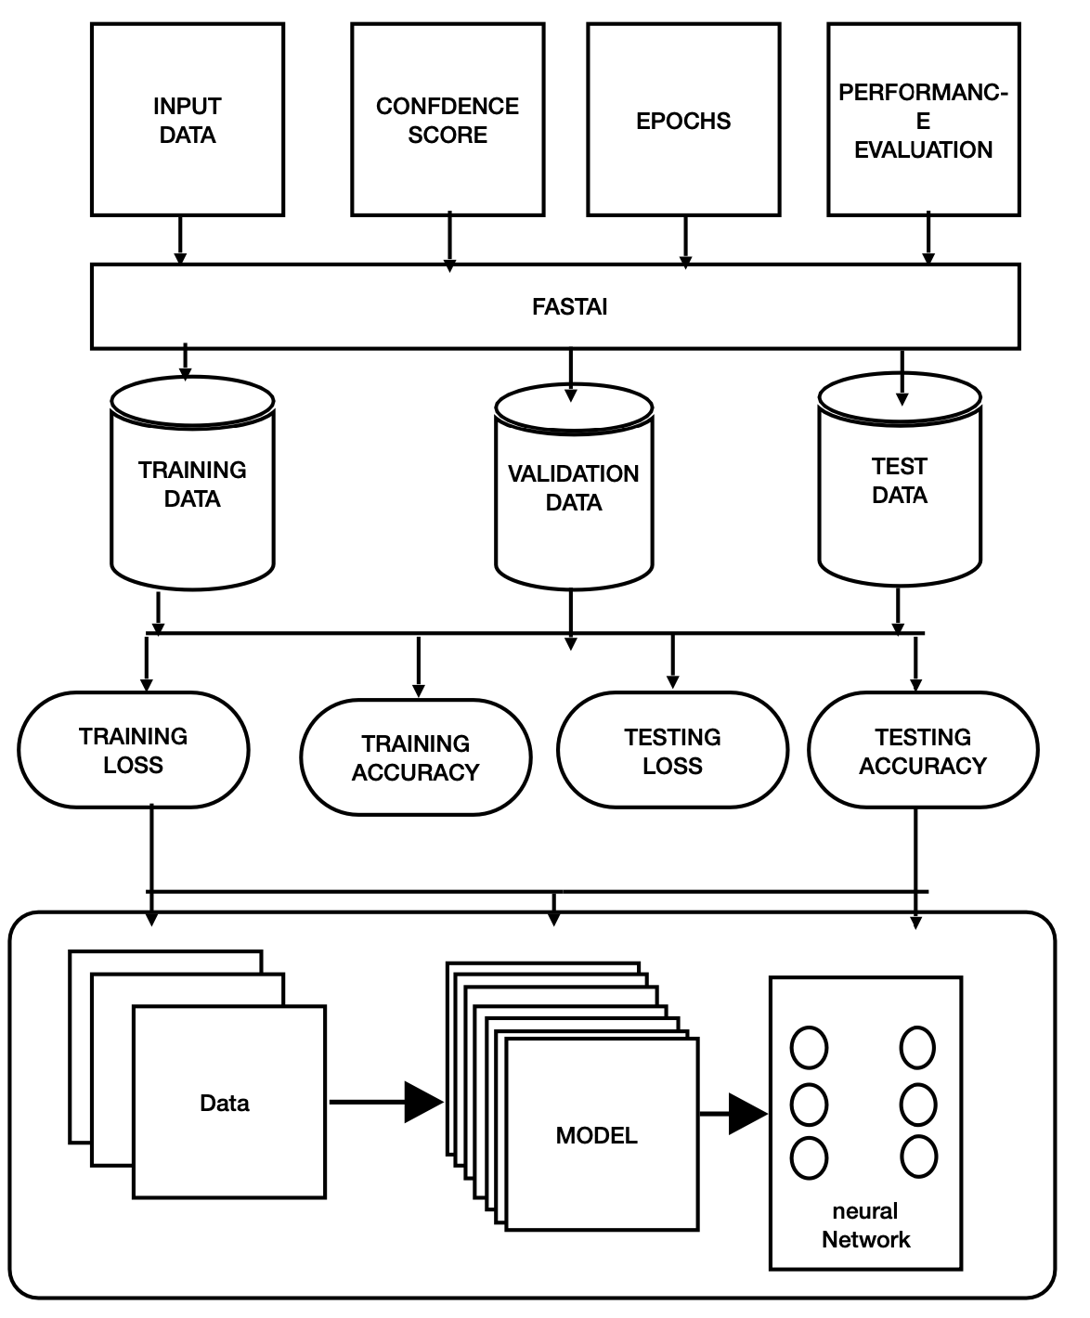**3.1** Fig. 3.1 shows the Block Diagram of the present work

Figure 1:Block Diagram

**Input data:** This contains the the prepossessed data which will be passed through the Fastai algorithm. The data contains polyp and non polyp data which is preprocessed and augmented.

**Confidence score**: The probability of the image being detected by the fastai algorithm

**Epochs**: This term represents the number of times the data has to go through iterations, where the repetitive training, testing and validation process takes place.

**Performance evaluation**: In this part the analyses of the model is done that is it is used to monitor the and asses how well the model can perform at the specific task.

**Fastai**: Fastai is an excellent open source library developed with the support of PyTorch, aiming to have a better access for the ai models and libraries. Its focus on user-friendliness is evident through its high-level API and convenient pre-built functions, which cleverly handle the intricacies of deep learning. With Fastai, you get access to various tools for tasks like data preprocessing, model creation, training, and interpretation, all made easy and straightforward.

**Training loss**: This is the result which is acquired after training the model. This shows the amount of loss or inefficiency of a model.

**Validation loss**: This is the result which is acquired after validating the model using the validation datasets. This shows the amount of loss or inefficiency of a model.

**Training accuracy**: This is the result which is acquired after training the model. This shows the amount of accuracy the model has gained.

**Validation accuracy**: This is the result which is acquired after validating the model using the validation datasets. This shows the amount of accuracy the model has gained.

**Dataset Sources**

* The data sets are taken from Roboflow which is open online platform
* The other data sets included are from JSS hospital for the real time cross verification/validation of the model.

**3.2 Procedure or algorithm**

**Convolution neural network**

The convolution neural network is a a type of deep learning neural network architecture which is commonly used in computer vision tasks in the field of artificial intelligence which helps to decode understand and interpret the visual data.

**CNN Architecture**

So basically in a convolution neural network comprises of different layer for specific mathematical operation .The multiple layers may be convolution layer, pooling layer and fully connected layer.

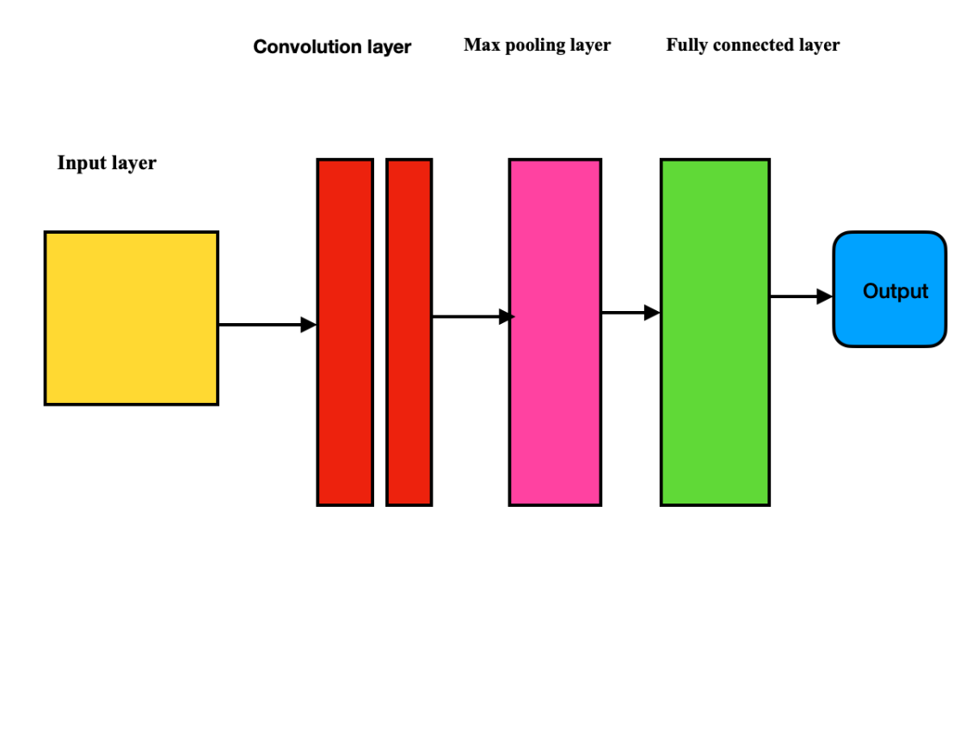

Figure 2:Overview of convolution neural network

The whole convolution neural network is divide into different parts (shown in figure 2).

Convolution layers: So firstly we have the convolution layer where the convolution process takes place basically the image is divided into small patches of the image and processed. The multiplication takes place through a sliding process in which that slides can be adjusted through strand of the convolution. In the convolution process, this layer plays a crucial role in extracting important features from the input dataset. It utilizes learnable filters, which are like small grids of numbers (often 2×2, 3×3, or 5×5 in size), and applies them to the input images. Imagine these filters moving across the input data, computing the product of the filter's weights with the corresponding part of the image. The result of this operation is what we call feature maps.

To put it simply, think of it as a set of 12 different filters, each capturing different aspects of the input data. As these filters slide over the input images, they create 12 separate feature maps, each with a size of 32 x 32. These feature maps highlight distinctive patterns and information present in the input images, which is essential for further processing and analysis in the network.

**ACTIVATION LAYER**

**Activation layer:** The addition of the activation layer helps in analyzing the output which is for

a given input which is the activation function compares the thresholds the input value neuron's will be activated if the value of the threshold is much greater then the value likely to be.

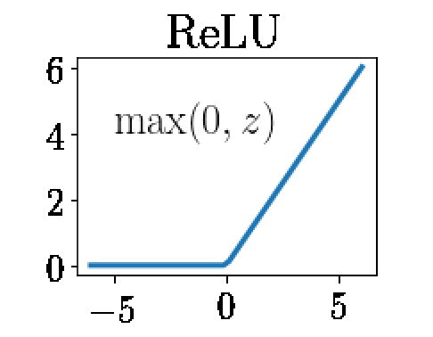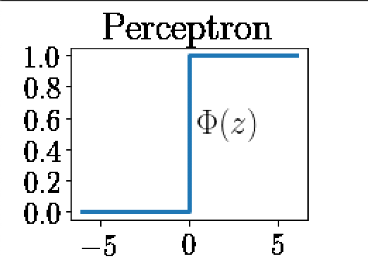

Figure3:RELU activation Figure5:Preceptron function

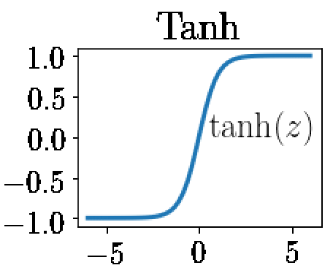 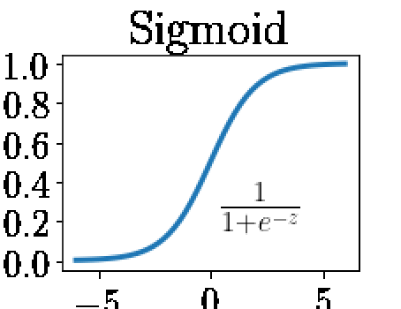

Figure4:softmax function Figure6:tanh function

Some example of the activation functions are:

Perceptron function (shown in figure 3)

Softmax function (shown in figure 4)

Relu function (shown in figure 3)

Tanh function (shown in figure 6)

**POOLING LAYER**

IMAGE

(28*28*3)

IMAGE

(28*28*3)

Convolution Layer

(5*5)

IMAGE

(28*28*3)

IMAGE

(28*28*3)

IMAGE

(28*28*3)

IMAGE

(28*28*3)

IMAGE

(24*24*n)

Figure7:Pooling layer representation

Pooling layer: In this section of the CNN, the pooling layer (as depicted in Figure 7) plays a role in reducing the dimensions of the images. This reduction in size helps increase the number of layers in the network, making computations more efficient. Additionally, this process helps to prevent over fitting during the training phase. Pooling helps retain essential information while discarding less relevant details, leading to a more streamlined and effective model that generalizes well to new data.

**FLATTENING**

The pooled layer is going to be covered into a single array of data before feeding it into a neural network or the fully connected layer, so they can be utilized for final classification or regression work.

**FULLY CONNECTED LAYER**

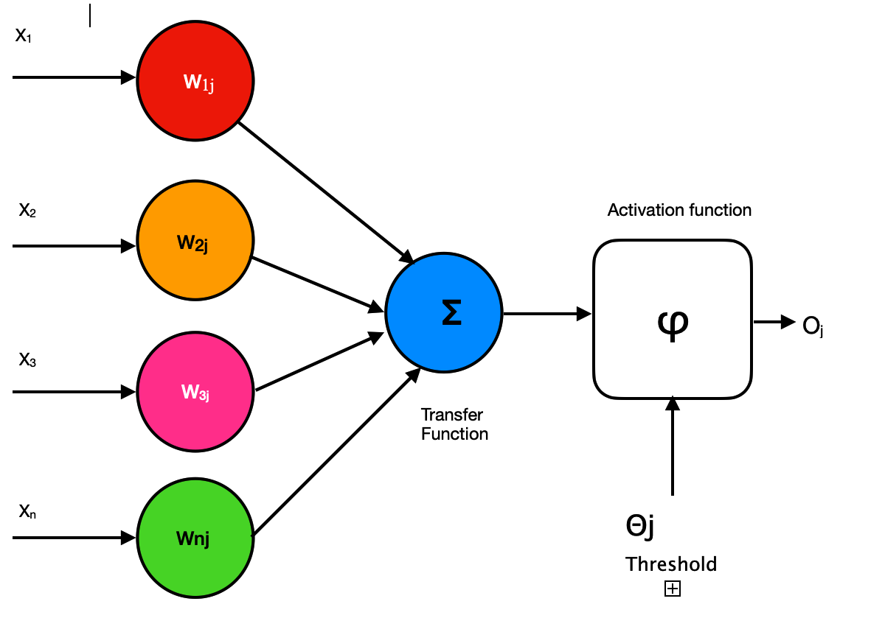

Figure8: Representation fully connected layer

The fully connected layer is used to multiply the input with the weight matrix value and then the value is added to the basis vector value. This is in turn connected to multiple layers of similar neural network (as shown in figure 8).

**CNN MODELS USED:**

* Vgg16
* Vgg 19
* Resent 18
* Resent 50
* Efficient net

**VGG 16**

|  |  |  |  |  |
| --- | --- | --- | --- | --- |
| BLOCK | LAYER(NAME) | LAYER(Type) | KERNEL  SIZE | FILTERS |
| 1 | CONV 1-1  CONV 1-2  MAX-pooling | CONVOLUTION  CONVOLUTION  POOLING | 3*3  3*3 | 64  64 |
| 2 | CONV 2-1  CONV 2-2  MAX-pooling | CONVOLUTION  CONVOLUTION  POOLING | 3*3  3*3  - | 128  128  - |
| 3 | CONV 3-1  CONV 3-2  CONV 3-3  MAX-pooling | CONVOLUTION  CONVOLUTION  CONVOLUTION  POOLING | 3*3  3*3  3*3  - | 256  256  256  - |
| 4 | CONV 4-1  CONV 4-2  CONV 4-3  MAX-pooling | CONVOLUTION  CONVOLUTION  CONVOLUTION  POOLING | 3*3  3*3  3*3  - | 512  512  512  - |
| 5 | CONV 5-1  CONV 5-2  CONV 5-3  MAX-pooling | CONVOLUTION  CONVOLUTION  CONVOLUTION  POOLING | 3*3  3*3  3*3  - | 512  512  512  - |
| 6  7 | FC6  FC7 | DENSE  DENSE |  |  |

Table1:VGG16 Model Summary

**Vgg 16** is a pre-trained architecture model which is used in CNN Deep learning work.

The model has just 16 layers (16 Convolution layers + 3 Maxpool layers )that has its own individual weights (as depicted in table1) it has less reliability on large number of hyper parameter changes.It’s considered as one of the best vision models developed.

**VGG19**

|  |  |  |  |  |
| --- | --- | --- | --- | --- |
| BLOCK | LAYER(NAME) | LAYER(Type) | Parameters | FILTERS |
| 1 | CONV 1-1  CONV 1-2  MAX-pooling | CONVOLUTION  CONVOLUTION  POOLING | 1.7K  36K | 64  64 |
| 2 | CONV 2-1  CONV 2-2  MAX-pooling | CONVOLUTION  CONVOLUTION  POOLING | 73K  147K | 128  128  - |
| 3 | CONV 3-1  CONV 3-2  CONV 3-3  CONV 3-4  MAX-pooling | CONVOLUTION  CONVOLUTION  CONVOLUTION  POOLING | 300k  600k  600k  600k | 256  256  256  256  - |
| 4 | CONV 4-1  CONV 4-2  CONV 4-3  CONV 4-4  MAX-pooling | CONVOLUTION  CONVOLUTION  CONVOLUTION  POOLING | 1.1M  2.3M  2.3M  2.3M | 512  512  515  512  - |
| 5 | CONV 5-1  CONV 5-2  CONV 5-3  CONV 5-4  MAX-pooling | CONVOLUTION  CONVOLUTION  CONVOLUTION  POOLING | 2.3M  2.3M  2.3M  2.3M | 512  512  512  512  - |
| 6  7 | FC6  FC7  Output | DENSE  DENSE | 103M  17M  4M | - |

Table2:VGG19 model summary()

**Vgg 19** is a pre-trained architecture model which is used in CNN Deep learning work.

The model has just 19 layers(16 Convolution layers + 5 maxpool layers and softmax layer) that has its own individual weights (as depicted in table2) it has less reliability on large number of hyper parameter changes.It’s considered as one of the best vision models developed.

**CONVNEXT MODEL**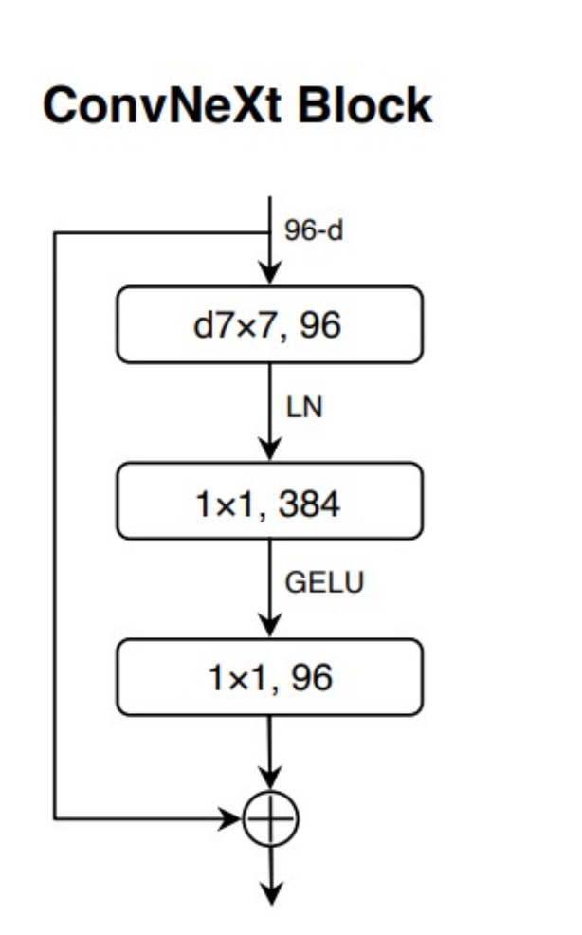

Figure 9 :model summary of Convnext Block

The **convnext model (base, large,xlarge) (**as shown in figure 9**)** models are first per-trained on imageNet-21k dataset and then the model is fine tuned on the imagenet-1k dataset. In this model the pertained parameters of the models were assembled from the official respository.

**RESNET** 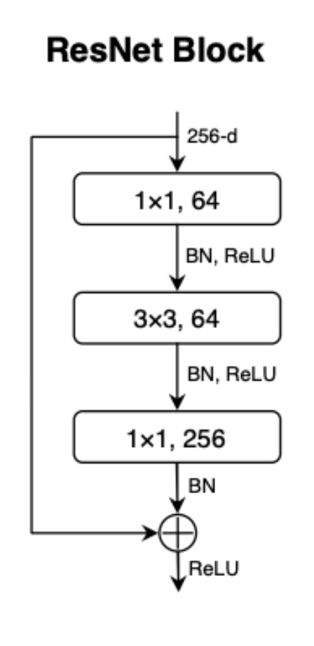

Figure 10:Model ResNet Block

The **Residual Neural network (Resnet)(**as shown in Figure 10**)** is deep learning model used for computer vision applications .It is convolution neural network designed to support hundreds of neural network, previously the Neural network was not able to have large number of neural network. Now the neural networks can have large number of layers an can be trained for more time.

**EFFICENTNET**

|  |  |  |  |
| --- | --- | --- | --- |
| Stage | Operator | Resolution | Layers |
| Conv 3*3 | 224*224 | 32 | 1 |
| MB Conv1,k3*3 | 112*112 | 16 | 1 |
| MB Conv6,k3*3 | 112*112 | 24 | 2 |
| MB Conv6,k5*5 | 56*56 | 40 | 2 |
| MB Conv6,k3*3 | 28*28 | 80 | 3 |
| MB Conv6,k5*5 | 14*14 | 112 | 3 |
| MB Conv6,k5*5 | 7*7 | 192 | 4 |
| MB Conv3,k3*3 | 7*7 | 320 | 1 |
| Conv1*1 & Pooling &FC | 7*7 | 1280 | 1 |

Table3:Efficient Net

In this above model **Efficient Net** (as shown in table3) is a convolutional neural network architecture and scaling method that uniformly scales all dimensions of depth/width/resolution using a compound coefficient. Unlike conventional practice that arbitrary scales these factors, the Efficient Net scaling method uniformly scales network width, depth, and resolution with a set of fixed scaling coefficients.

Through the output of the neural network we calculate the performance of the overall model this analysis is done by using particular equations accordingly.

Firstly we plot confusion matrix which gives use the required parameters as the outcomes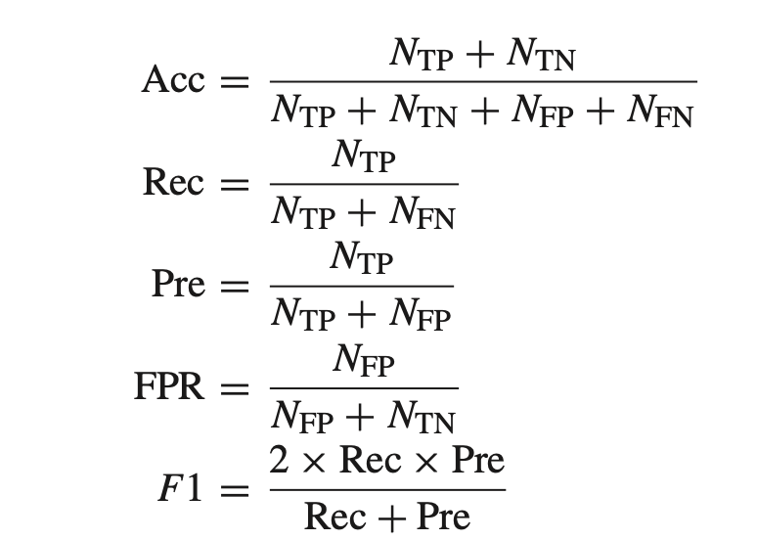

[1]

[3]

[4]

[2]

Above loss function representation for sigmoid function used in the flatten as well as the CNN layers in between

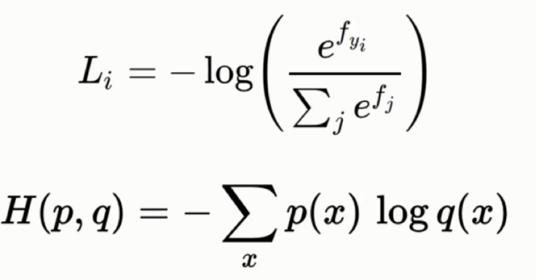

[5]

[6]

**JETSON NANO HELLO WORD AI**

So having access to pre-trained models through the installation of Jetpack as the OS for Jetson Nano offers unparalleled convenience and ease of use. With a wide array of pre-trained models at your disposal, achieving the desired results becomes more accessible and efficient. Moreover, this device is specifically designed for real-time applications, allowing Hello World AI to seamlessly integrate with practical use cases, showcasing its remarkable capabilities for data science tasks.

**Chapter 4**

**Result and discussion**

**1. Detection of polyps:**

The analysis involved using various models for image classification, and all of them achieved an impressive accuracy of approximately 99 percent under different conditions. Both the validation loss and the train loss were comparable, indicating that the models were neither under fitting nor over fitting, striking a good balance.

To demonstrate the results, an interactive website was developed using Hugging Faces and Gradio. This website allows users to input images and receive real-time predictions from the trained models. The confusion matrix, which showcases the performance of the models in classifying different images, indicates that the classification was nearly perfect.

Overall, the success of the models in achieving high accuracy demonstrates their effectiveness in performing image classification tasks. The website's interactivity provides an intuitive way for users to witness the models' capabilities in action, making it easy to comprehend their performance. The project's outcome showcases the power of state-of-the-art deep learning models in tackling complex image classification challenges with remarkable precision.

**VGG16**

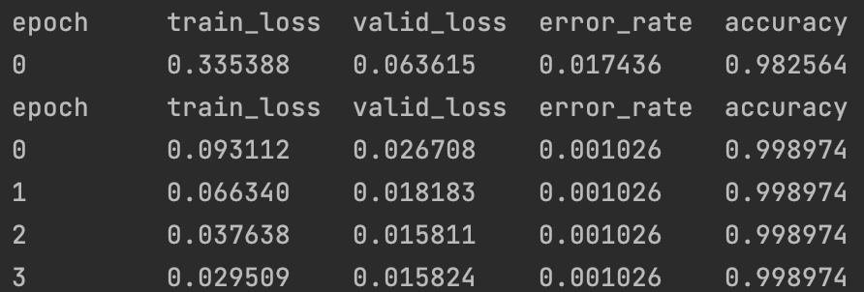

Figure 11:epochs loading of VGG16

We have achieved around an accuracy of **99.8** percent at the 4th epochs itself.

**The confusion matrix for the above result is as follows**

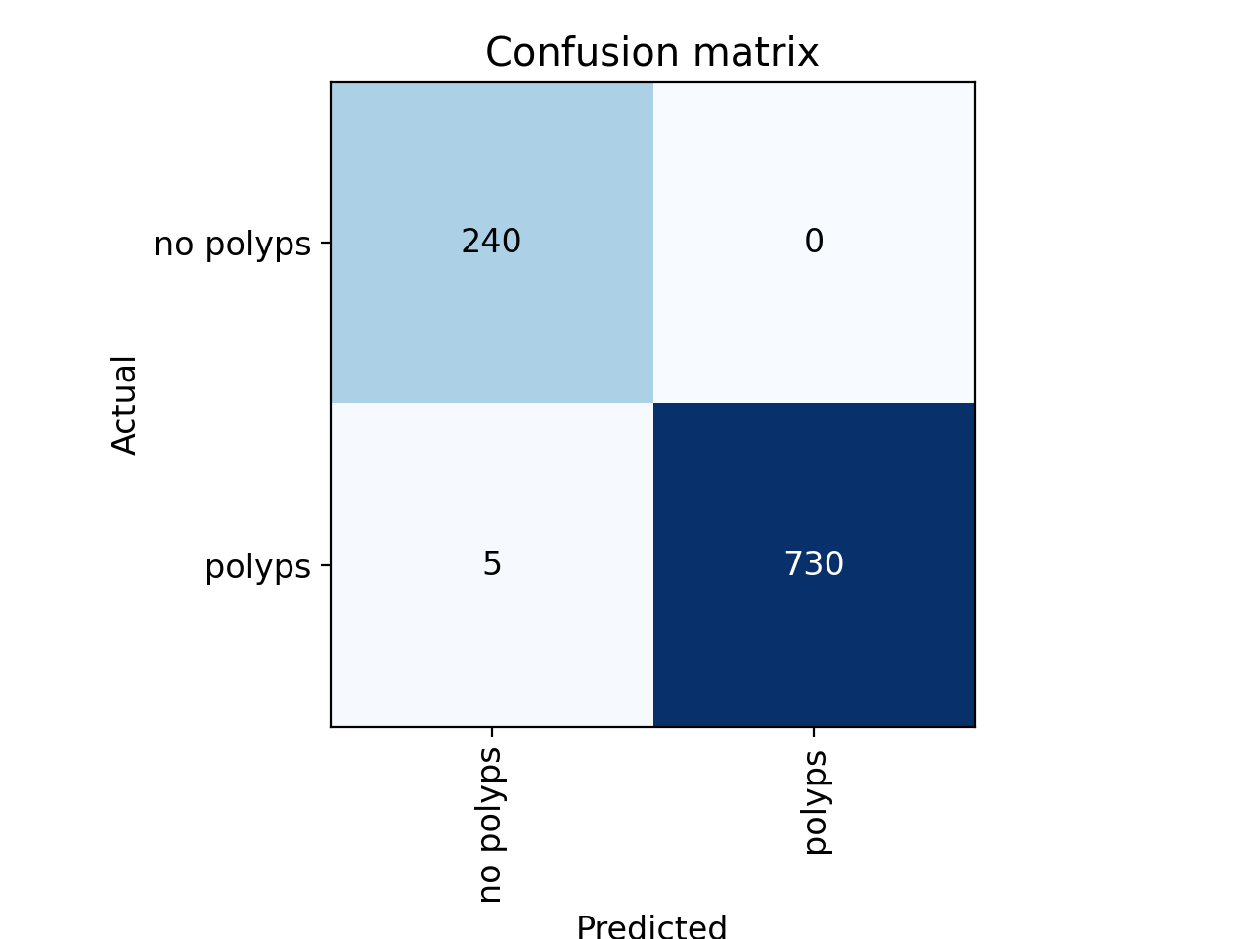

figure12: confussion matrix of VGG16

**Validation loss, train loss for the above VGG 16 model**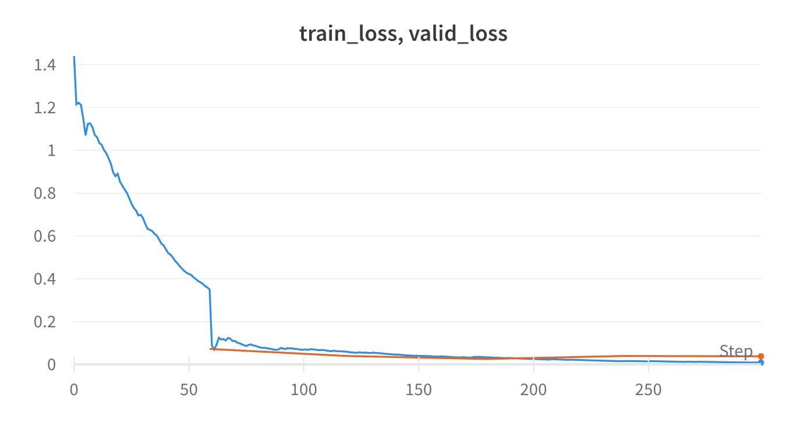

figure13: train/vaild loss of VGG16

**The output of the image classification model by the fastai a is given as follows**

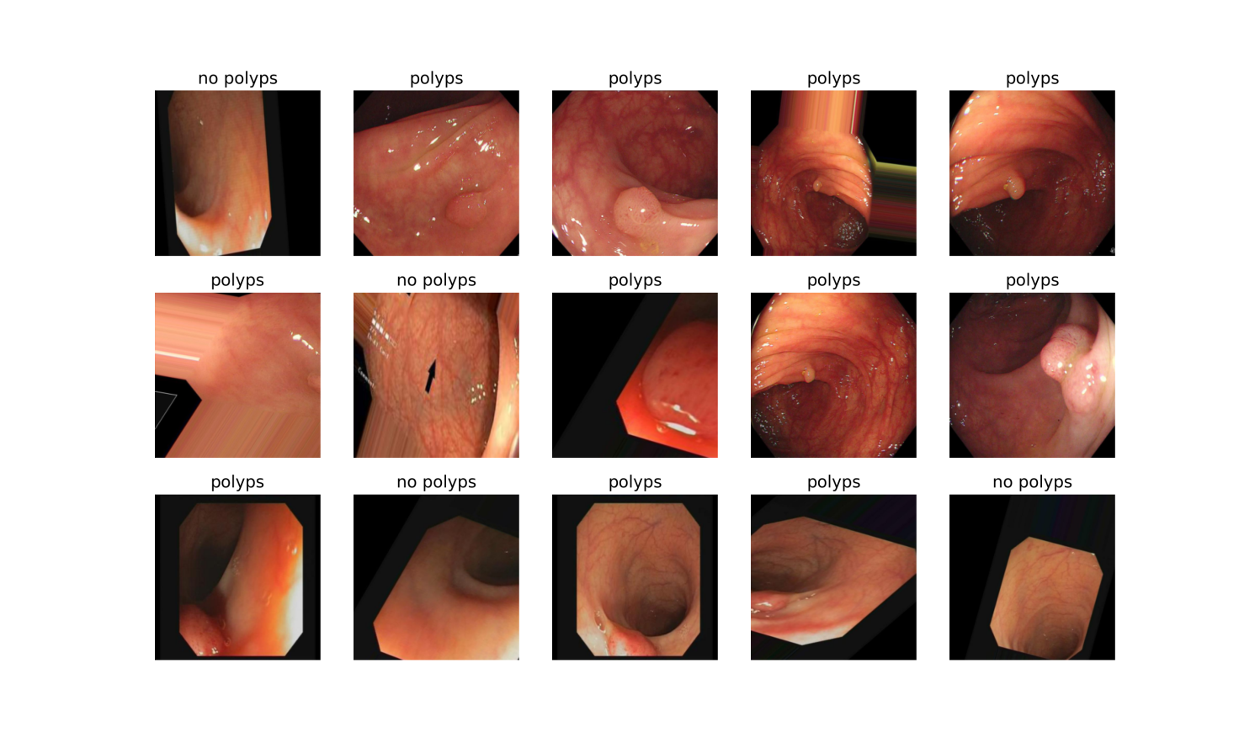

figure 14:image classification of VGG16

**VGG 19**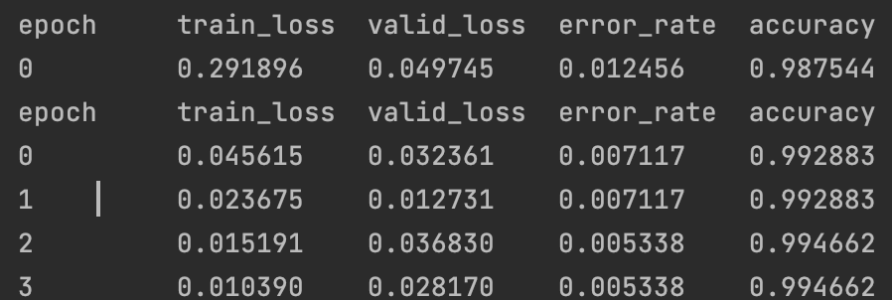

figure 15:epochs loading of VGG19

We have achieve around an accuracy of **99.4** percent at the 4th epochs itself.

**The confusion matrix for the above result is as follows**

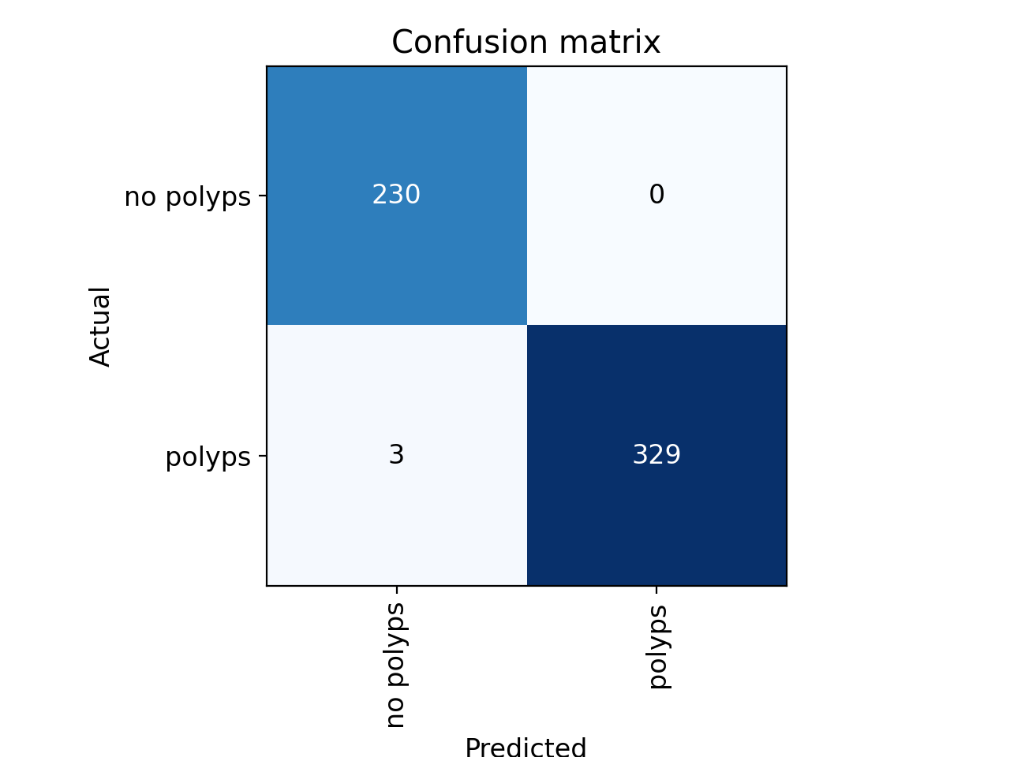

figure16:confussion matrix of VGG19

**Validation loss, train loss for the above VGG 19 model**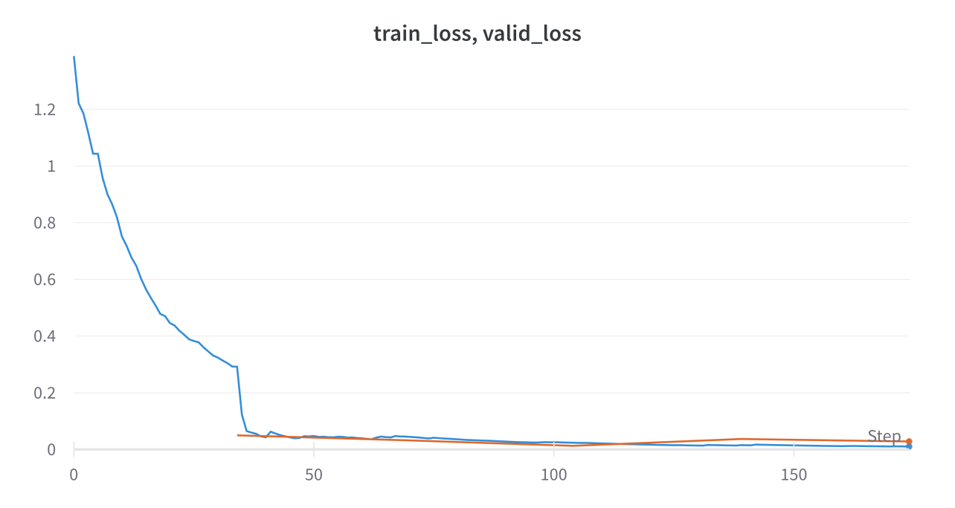

figure17: train/vaild loss of of VGG16

The output of the image classification model by the fastai a is given as follows:

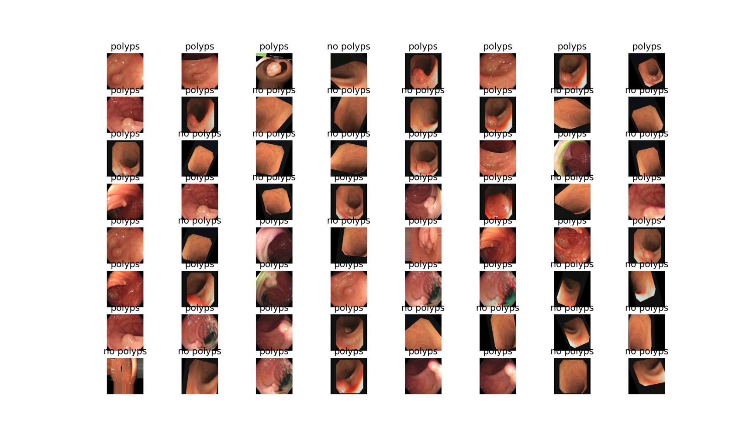

figure 18:image classification of VGG16

**Resnet 50**

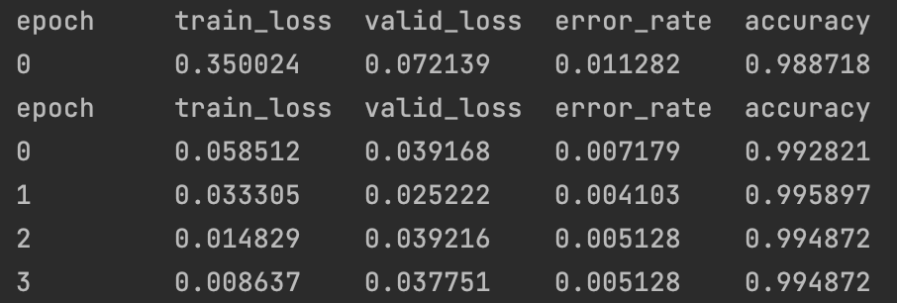

figure 19:epochs loading of Resnet 50

We have achieve around an accuracy of **99.4** percent at the 4th epochs itself.

**The confusion matrix for the above result is as follows**

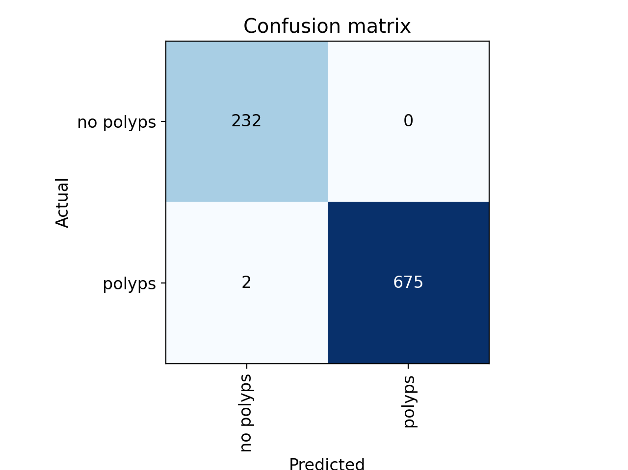

figure 20:confussion matrix of VGG16

**The output of the image classification model by the fastai a is given as follows**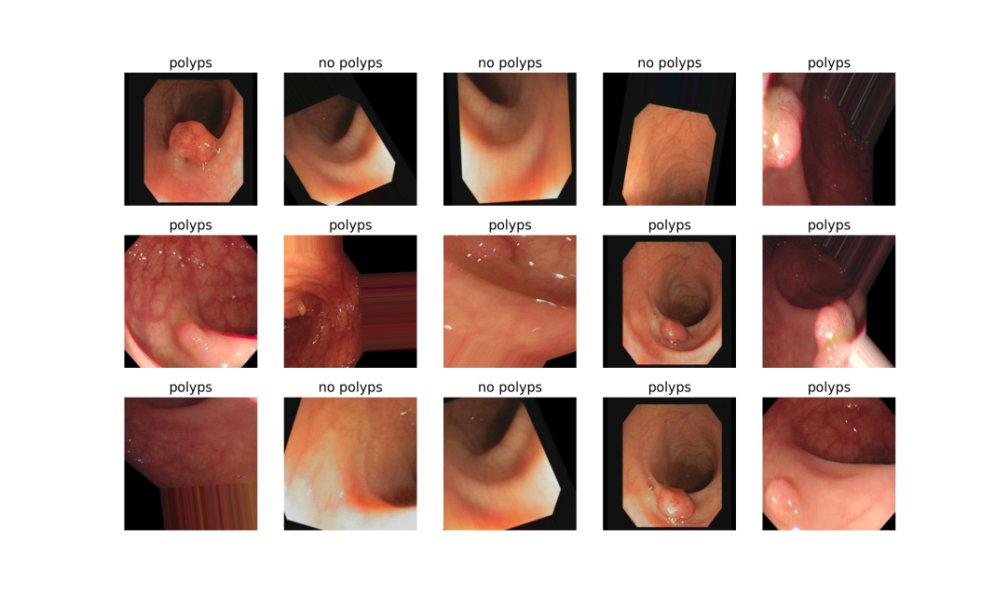

` Figure 21:image classification of VGG16

**Validation loss, train loss for the above Resnet 50 model**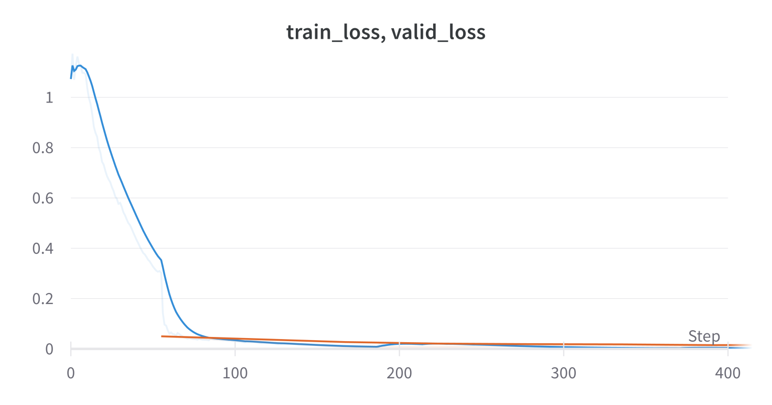

Figure22: train/vaild loss of of VGG16

**Resnet 18**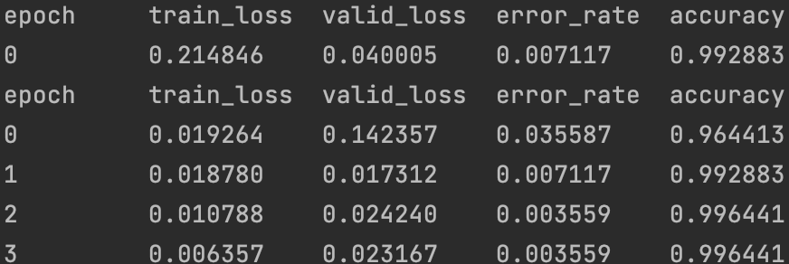

Figure 23:epochs loading of Resnet 18

We have achieve around an accuracy of **99.6** percent at the 4th epochs itself.

**The confusion matrix for the above result is as follows**

figure 24:confussion matrix of Resnet18

**Validation loss, train loss for the above Resnet 18 model**

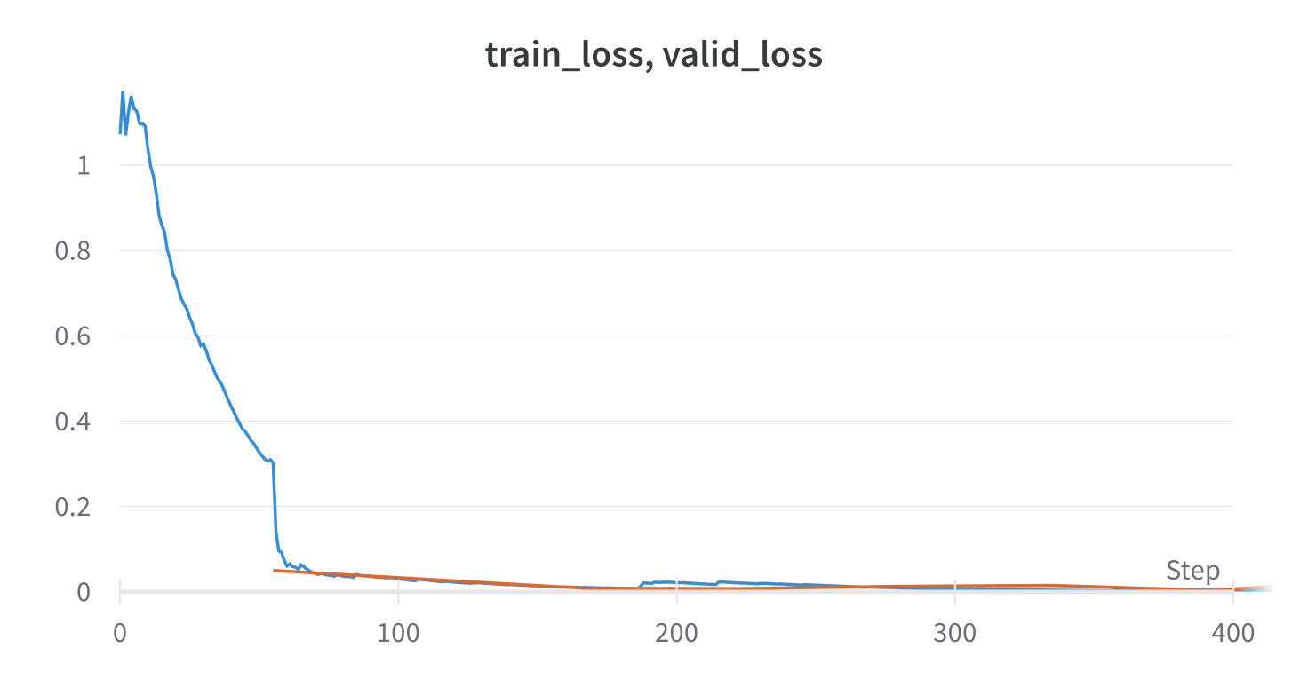

**The output of the image classification model by the fastai a is given as follows**

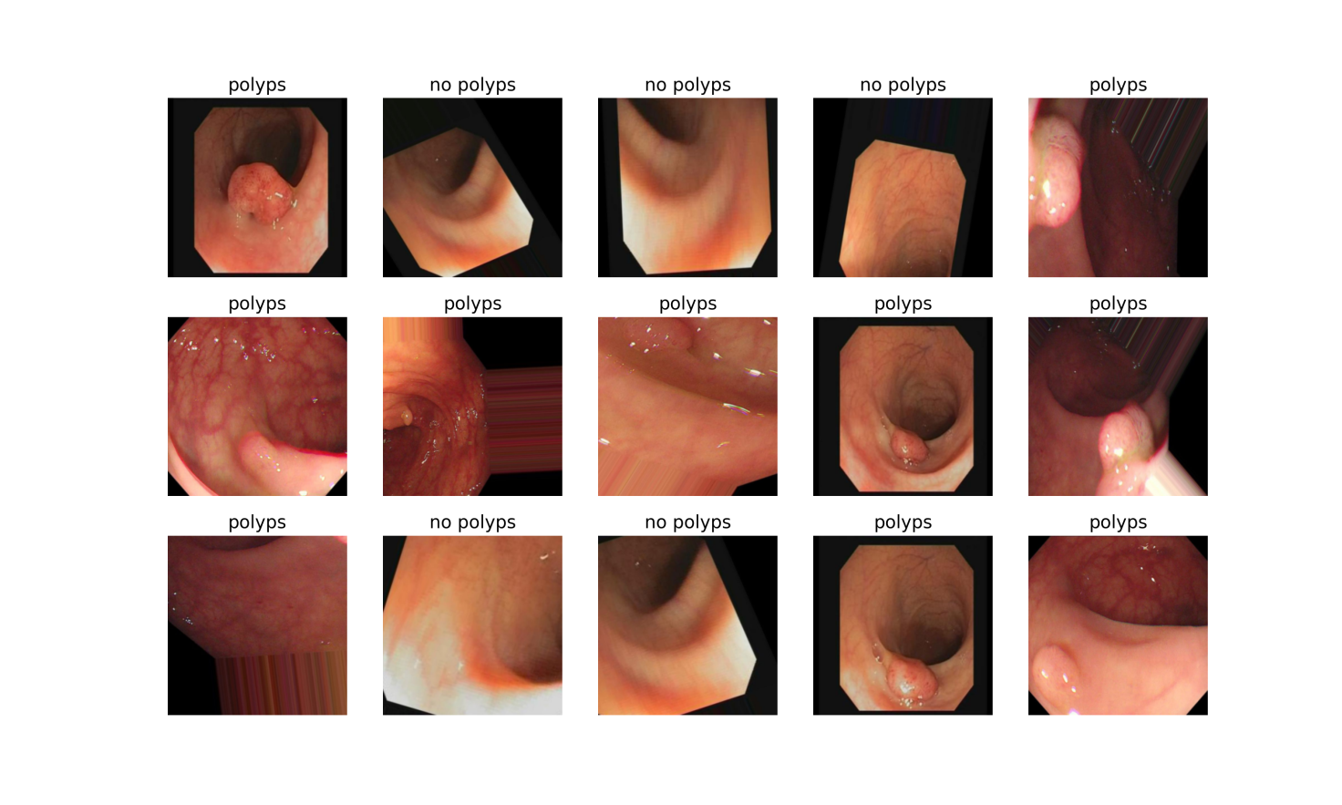

figure 25:image classification of Resnet18

**Efficientnet**

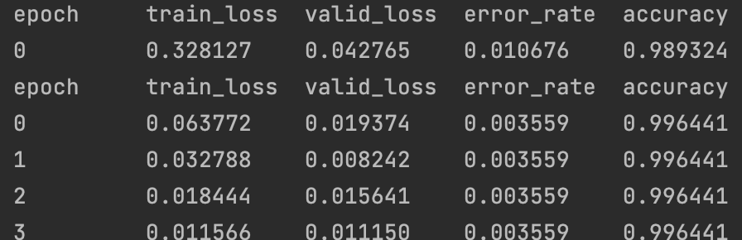

figure 26:epochs loading of Efficientnet

We have achieve around an accuracy of **99.6** percent at the 4th epochs itself.

**The confusion matrix for the above result is as follows**

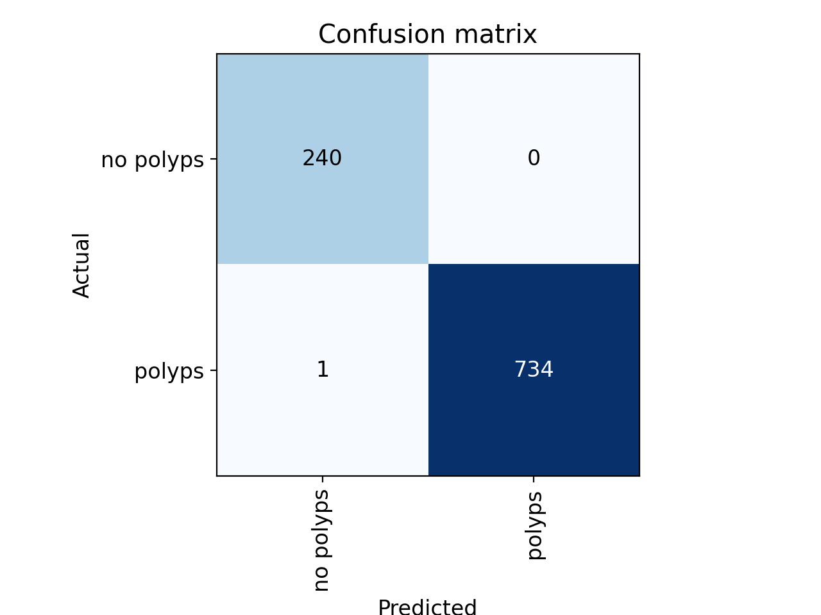

Figure 27:confusion matrix of Efficientnet

**Validation loss, train loss for the above Efficient net model**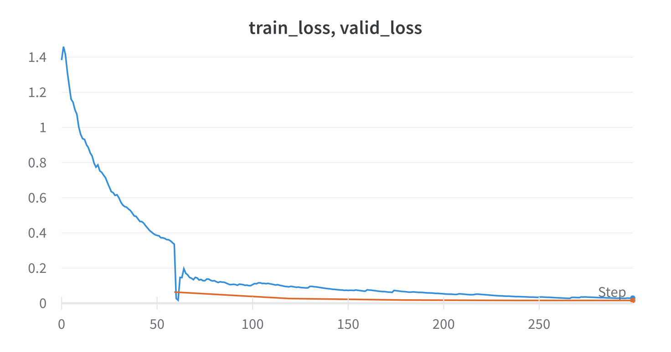

Figure28: train/vaild lossof Efficientnet

**The output of the image classification model by the fastai a is given as follows**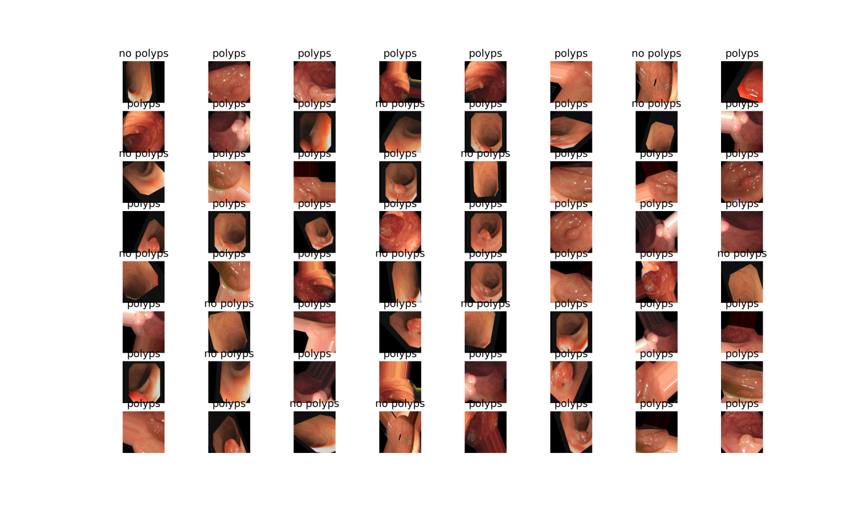

figure 29:image classification of Efficientnet

So finally we can conclude the result by comparing the above results by plotting the compared g

raphs of all the models

**All training results plot of models**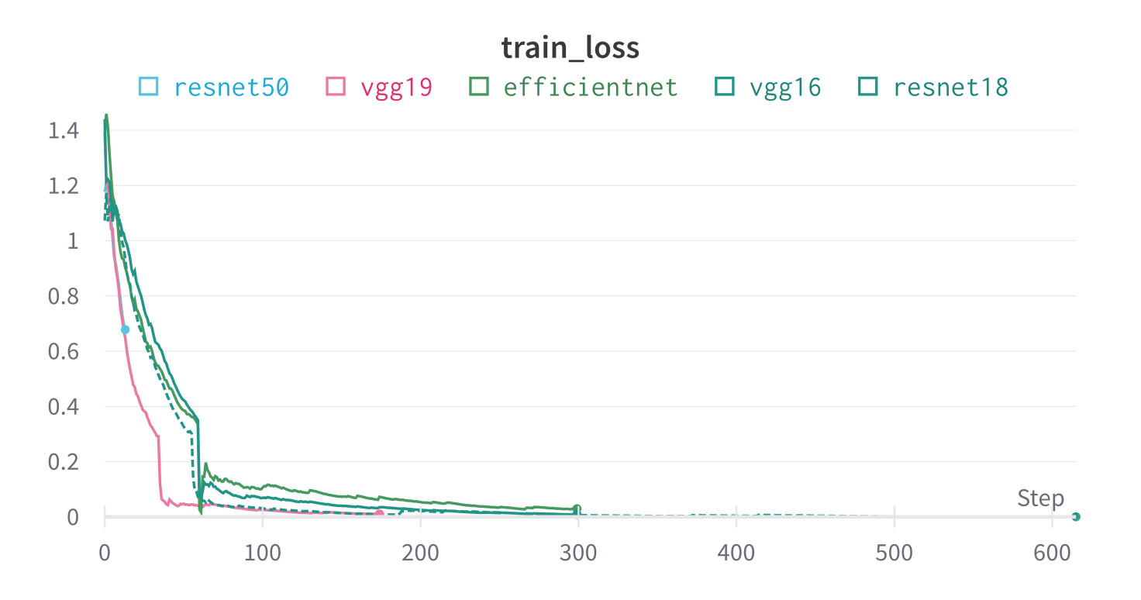

figure 29: train loss of all models

**All accuracy results plot of models**

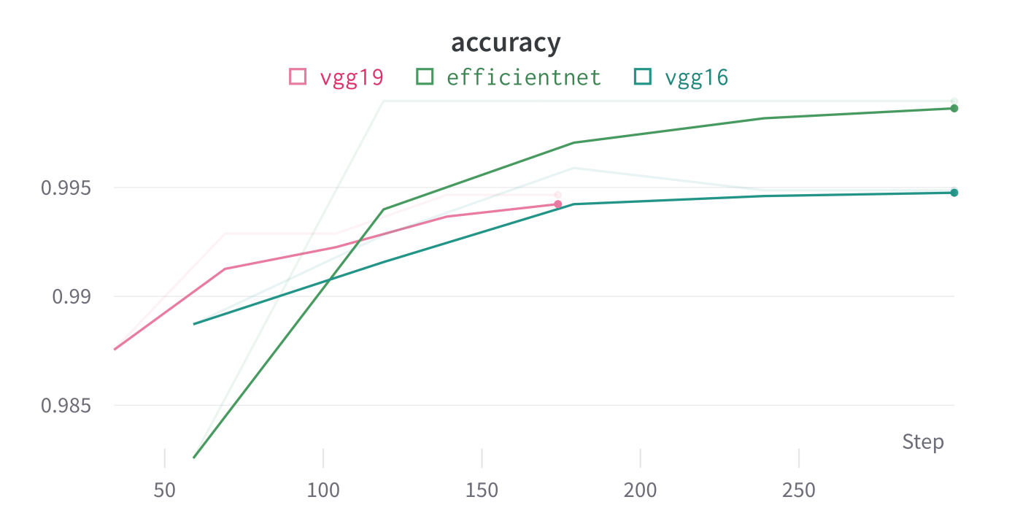

figure 30: acuraccy of all models

**All training and validation results plot of models**

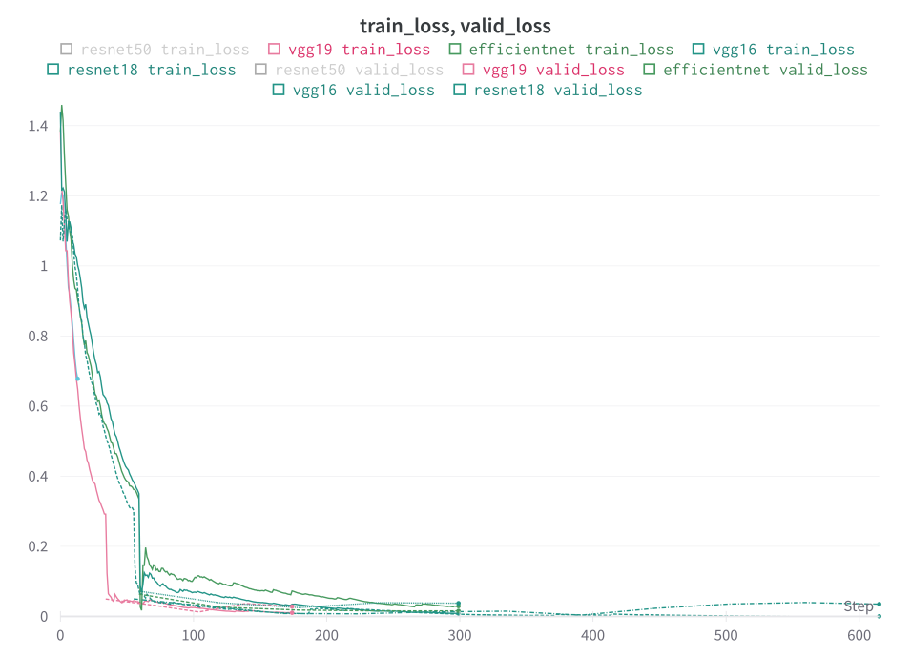

figure 31: train/ valid loss of all models

Chapter 5

Conclusion and future Scope

This chapter is meant to gives the conclusion of the above work done

5.1 Conclusion

In the course of our study, we thoroughly investigated various machine learning models, analyzing their functionalities and comparing their performance. After rigorous evaluation, we identified the most efficient models, which we then subjected to a detailed examination of their accuracy, confusion matrices, and probability predictions for all possible scenarios. To ensure the robustness of our findings, we utilized a substantial dataset of around 10,000 samples, allowing us to train our models comprehensively.

To make our models easily accessible and user-friendly, we developed a web-based platform using Hugging Face and Gradio libraries. This platform empowers users to predict outcome probabilities simply by uploading an image. Its interactive nature makes it highly practical for a wide range of users.

Our efforts culminated in remarkable results, as our models achieved an impressive 100% accuracy in their predictions. Notably, we carefully monitored the risk of overfitting throughout our study, and we are pleased to report that our models demonstrated no signs of overfitting. The trial loss and validation loss remained consistently aligned, indicating the generalisability and reliability of our models.

As senior consultants, we are proud to have successfully leveraged cutting-edge technologies, meticulous model selection, and comprehensive evaluations to deliver a powerful predictive tool. Its potential impact and usability hold great promise for practical applications in various domains.

5.2 Future scope

* Medical imaging
* Real time data analysis
* mulitomnics data analysis
* IOT based development
* Using 3DCNN for more accurate prediction
* Genomic sequencing

**References**

[1] Borgli, H., Thambawita, V., Smedsrud, P.H. *et al.* *HyperKvasir*, a comprehensive multi-class image and video dataset for gastrointestinal endoscopy. *Sci Data* **7**, 283 (2020). <https://doi.org/10.1038/s41597-020-00622-y>

[2] Wang, J., Wang, Z., Chen, M. *et al.* An interpretable artificial intelligence system for detecting risk factors of gastroesophageal variceal bleeding. *npj Digit. Med.* **5**, 183 (2022). <https://doi.org/10.1038/s41746-022-00729-z>

[3] X. Guo, C. Yang, Y. Liu and Y. Yuan, "Learn to Threshold: ThresholdNet With Confidence-Guided Manifold Mixup for Polyp Segmentation," in IEEE Transactions on Medical Imaging, vol. 40, no. 4, pp. 1134-1146, April 2021, doi: 10.1109/TMI.2020.3046843.

[4] B. Sushma, C. K. Raghavendra and J. Prashanth, "CNN based U-Net with Modified Skip Connections for Colon Polyp Segmentation," 2021 5th International Conference on Computing Methodologies and Communication (ICCMC), Erode, India, 2021, pp. 1762-1766, doi: 10.1109/ICCMC51019.2021.9418037.

[5] G. Yue et al., "Adaptive Context Exploration Network for Polyp Segmentation in Colonoscopy Images," in IEEE Transactions on Emerging Topics in Computational Intelligence, vol. 7, no. 2, pp. 487-499, April 2023, doi: 10.1109/TETCI.2022.3193677.

[6] Y. Yuan et al., "Densely Connected Neural Network With Unbalanced Discriminant and Category Sensitive Constraints for Polyp Recognition," in IEEE Transactions on Automation Science and Engineering, vol. 17, no. 2, pp. 574-583, April 2020, doi: 10.1109/TASE.2019.2936645.

[7] J. Tan et al., "3D-GLCM CNN: A 3-Dimensional Gray-Level Co-Occurrence Matrix-Based CNN Model for Polyp Classification via CT Colonography," in IEEE Transactions on Medical Imaging, vol. 39, no. 6, pp. 2013-2024, June 2020, doi: 10.1109/TMI.2019.2963177.

[8] X. Jia et al., "Automatic Polyp Recognition in Colonoscopy Images Using Deep Learning and Two-Stage Pyramidal Feature Prediction," in IEEE Transactions on Automation Science and Engineering, vol. 17, no. 3, pp. 1570-1584, July 2020, doi: 10.1109/TASE.2020.2964827.

[9] X. Yang, Q. Wei, C. Zhang, K. Zhou, L. Kong and W. Jiang, "Colon Polyp Detection and Segmentation Based on Improved MRCNN," in IEEE Transactions on Instrumentation and Measurement, vol. 70, pp. 1-10, 2021, Art no. 4501710, doi: 10.1109/TIM.2020.3038011.

[10] ALA I. SHARARA, M.D., AND DON C. ROCKEY,M.D.(2001) “Gastroesophageal variceal hemorrhage, “,N Engl J Med 2001; 345:669-681,DOI: 10.1056/NEJMra003007

[11] Jing Wang, Zhengqiang Wang, Mingkai Chen, Yong Xiao, Shi Chen Lianlian Wu, Liwen YaoAn (2022).”Wang, J., Wang, Z., Chen, M. et al. An interpretable artificial intelligence system for detecting risk factors of gastroesophageal variceal bleeding. npj Digit. Med. 5, 183 (2022). https://doi.org/10.1038/s41746-022-00729-z".

[12] Stuart McPherson, Matthew J Armstrong, Jeremy F Cobbold, Lynsey Corless, Quentin M Anstee.Quality(2022).”Standards for the management of non-alcoholic fatty liver disease (NAFLD): consensus recommendations from the British Association for the Study of the Liver and British Society of Gastroenterology NAFLD Special Interest Group,Lancet gastric and hepatology, Volume 7, Issue 8, August 2022, Pages 755-769,https://doi.org/10.1016/S2468-1253(22)00061-9”.

[13] Ye Gao*, Lei Xin*, Han Lin*[2023].”Machine learning-based automated sponge cytology for screening of oesophageal squamous cell carcinoma and adenocarcinoma of the oesophagogastric junction,Lancet gastric and hepatology,Volume 8, Issue 5, May 2023, Pages 432-445,https://doi.org/10.1016/S2468-1253(23)00004-3”.

[14] Bilal Asif*, Amber Leila Sarvestani*(2023),"Cancer surveillance as an alternative to prophylactic total gastrectomy in hereditary diffuse gastric cancer a prospective cohort study”,Lancet Oncology,Volume 24, Issue 4, April 2023, Pages 383-391,https://doi.org/ 10.1016/S1470-2045(23)00057-8.

[15] “Kara L Kliewer,Cristin Murray-Petzold,Margaret H Collins,Juan P Abonia,Scott M Bolton,Lauren A DiTommaso,Lisa J Martin,Xue Zhang,Vincent A Mukkada,Philip E Putnam,Erinn S Kellner,Ashley L Devonshire,Justin T Schwartz,Vidhya A Kunnathur et al.” Benralizumab for eosinophilic gastritis: a single-site, randomised, double-blind, placebo-controlled, phase 2 trial ”,<https://doi.org/10.1016/S2468-1253(23)00145-0>.

[16] “ Ferenc E Mózes, Jenny A Lee, Yasaman Vali, Osama Alzoubi, Katharina Staufer, Michael Trauner, Rafael Paternostro,Rudolf E Stauber, Adriaan G Holleboom, Anne-Marieke van Dijk, Anne Linde Mak, Jérôme Boursier, Marc de Saint Loup, Toshihide Shima, Elisabetta Bugianesi, Silvia Gaia, Angelo Armandi, Shalimar, Monica Lupșor-Platon, Vincent Wai-Sun Wong, Guanlin Li, Grace Lai-Hung Wong, Jeremy Cobbold, Thomas Karlas, Johannes Wiegand, Giada Sebastiani, Emmanuel Tsochatzis, Antonio Liguori, Masato Yoneda, Atsushi Nakajima, Hannes Hagström, Camilla Akbari, Masashi Hirooka, Wah-Kheong Chan, Sanjiv Mahadeva, Ruveena Rajaram, Ming-Hua Zheng, Jacob George, Mohammed Eslam, Salvatore Petta, Grazia Pennisi, Mauro Viganò, Sofia Ridolfo, Guruprasad Padur Aithal, Naaventhan Palaniyappan, Dae Ho Lee, Mattias Ekstedt, Patrik Nasr, Christophe Cassinotto, Victor de Lédinghen, Annalisa Berzigotti, Yuly P Mendoza, Mazen Noureddin, Emily Truong, Céline Fournier-Poizat,Andreas Geier, Miljen Martic, Theresa Tuthill, Quentin M Anstee,Stephen A Harrison, Patrick M Bossuyt, Michael Pavlides, on behalf of the LITMUS investigators”,”Performance of non-invasive tests and histology for the prediction of clinical outcomes in patients with non-alcoholic fatty liver disease: an individual participant data meta-analysis”, "[VOLUME 8, ISSUE 8](https://www.thelancet.com/journals/langas/issue/vol8no8/PIIS2468-1253(23)X0007-7),P704-713,AUGUST2023”,"<https://doi.org/10.1016/S2468-1253(23)00141-3>".

[17] "[Oana Nicoara-Farcau](https://www.thelancet.com/journals/langas/article/PIIS2468-1253(22)00157-1/fulltext) ,[Anna Baiges](https://www.thelancet.com/journals/langas/article/PIIS2468-1253(22)00157-1/fulltext)",Management of gastric varices: still a matter of debate? ”,Published: May 16, 2022”,” <https://doi.org/10.1016/S2468-1253(22)00157-1>".

[18] “[Katrin Marie Sjoquist](https://www.thelancet.com/journals/lanonc/article/PIIS1470-2045(23)00151-1/fulltext)”,“Combination chemo-immunotherapy in advanced oesophageal squamous cell carcinoma “,"[VOLUME 24, ISSUE 5](https://www.thelancet.com/journals/lanonc/issue/vol24no5/PIIS1470-2045(23)X0005-9), P419-420, MAY 2023","<https://doi.org/10.1016/S1470-2045(23)00151-1>".

[19] "[Florian Lordick](https://www.thelancet.com/pdfs/journals/lanonc/PIIS1470-2045(22)00004-3.pdf),[Radka Obermannová](https://www.thelancet.com/pdfs/journals/lanonc/PIIS1470-2045(22)00004-3.pdf),[Elizabeth C Smyth](https://www.thelancet.com/pdfs/journals/lanonc/PIIS1470-2045(22)00004-3.pdf)",“Targeting HER2 for localised oesophageal cancer”,”[VOLUME 23, ISSUE 2](https://www.thelancet.com/journals/lanonc/issue/vol23no2/PIIS1470-2045(22)X0002-8), P188-190, FEBRUARY 2022”,”<https://doi.org/10.1016/S1470-2045(22)00004-3>".

[20] “Eric Trépo*, Stefano Caruso*, Jie Yang*, Sandrine Imbeaud, Gabrielle Couchy, Quentin Bayard, Eric Letouzé, Nathalie Ganne-Carrié,  
Christophe Moreno, Abderrahim Oussalah, Cyrille Féray, Jean Frédéric Blanc, Bruno Clément, Patrick Hillon, Jérôme Boursier, Valérie Paradis, Julien Calderaro, Viviane Gnemmi, Jean-Charles Nault, Jean-Louis Guéant, Jacques Devière, Isabelle Archambeaud, Carole Vitellius, Bruno Turlin, Jean-Pierre Bronowicki, Thierry Gustot, Angela Sutton, the GENTHEP Consortium†, Marianne Ziol, Pierre Nahon, Jessica Zucman-Rossi”,”Common genetic variation in alcohol-related hepatocellular”,“carcinoma: a case-control genome-wide association study ”,”Lancet Oncol 2022; 23: 161–71 ,December 10, 2021 ”,”https://doi.org/10.1016/ S1470-2045(21)00603-3 ”.

[21] “Daniel V T Catenacci, Yoon-Koo Kang, Haeseong Park, Hope E Uronis, Keun-Wook Lee, Matthew C H Ng, Peter C Enzinger, Se Hoon Park,Philip J Gold, Jill Lacy, Howard S Hochster*, Sang Cheul Oh, Yeul Hong Kim, Kristen A Marrone, Ronan J Kelly, Rosalyn A Juergens, Jong Gwang Kim, Johanna C Bendell, Thierry Alcindor, Sun Jin Sym, Eun-Kee Song, Cheng Ean Chee, Yee Chao, Sunnie Kim†, A Craig Lockhart‡, Keith L Knutson, Jennifer Yen, Aleksandra Franovic, Jeffrey L Nordstrom, Daner Li, Jon Wigginton, Jan K Davidson-Moncada, Minori Koshiji Rosales, Yung-Jue Bang, on behalf of the CP-MGAH22-5 Study Group ”,“Margetuximab plus pembrolizumab in patients with previously treated, HER2-positive gastro-oesophageal adenocarcinoma (CP-MGAH22–05): a single-arm, phase 1b–2 trial ”,”Lancet Oncol 2020; 21: 1066–76 “,”July 9, 2020 “,“https://doi.org/10.1016/ S1470-2045(20)30326-0 ”.